Meta title: Optimize Community Home Health Care: Key Benefits & Strategies
Meta description: Discover how community home health care services enhance recovery and independence at home, bridging hospital discharge with expert medical support.

Enhancing Community Home Health Care Services

You finally get the news that your loved one is ready for discharge, but relief quickly turns to panic when you realize you are now in charge of their recovery. Instead of managing complex medications and wound dressings alone, imagine bringing the doctor’s orders directly into your living room. This is the critical role of community home health care, a service designed to act as a bridge between a sterile hospital ward and the comfort of a family home.
Many families initially confuse this service with non-medical "home care," which focuses on helping with daily chores like cooking or bathing. In contrast, clinical home health is a medical powerhouse. It involves licensed professionals—such as registered nurses and physical therapists—performing skilled services that were once limited to medical facilities.
Think of these visiting professionals as the physician's eyes and ears at the kitchen table. By monitoring vitals and tracking recovery progress, they ensure that transitioning from hospital to home is safe rather than a scramble for survival. According to data from the Centers for Medicare & Medicaid Services, patients who receive timely home health visits are significantly less likely to face emergency readmissions.
The ultimate goal extends beyond just healing an incision or managing a chronic condition. Proper clinical support unlocks the true potential of aging in place benefits, allowing patients to recover independence in the environment where they feel most like themselves.

Why Staying Home Beats the Nursing Home: The Real Benefits of Aging in Place
Recovering in a familiar environment does more than just boost morale; it actually speeds up the healing process. For an aging parent, waking up in their own bed rather than a noisy, shared hospital room significantly reduces confusion and anxiety. This mental clarity is a crucial component of recovery, as patients who feel safe and oriented are much more likely to sleep better, eat well, and stick to their medication schedules.
Safety plays an equally massive role in the decision to choose home health vs nursing home care. Hospitals and rehab centers, despite their best efforts, concentrate sick people in one place, which inevitably increases the risk of exposure to new illnesses. By contrast, your home is a controlled environment where the biology is familiar, drastically lowering the chance of contracting a hospital-acquired infection during a vulnerable recovery period.
When managed correctly, aging in place benefits the patient by delivering measurable clinical advantages over institutional care:
- Lower Infection Risk: Avoiding exposure to resistant bacteria and viruses common in large facilities.
- Faster Mobility Gains: Patients practice walking in their real environment, navigating their own rugs and stairs rather than a generic gym floor.
- Improved Mental Well-being: Significantly lower rates of depression and isolation compared to extended facility stays.
Capitalizing on these benefits requires distinguishing between the medical support that heals and the daily assistance that helps.

Skilled Nursing vs. Personal Care: Decoding the Differences in the Help You Receive
Navigating the terminology of community home care implies learning a new language, especially when trying to determine exactly what kind of professional needs to walk through your front door. The most critical distinction lies between "skilled nursing" and "personal care." While often used interchangeably in casual conversation, these represent two completely different levels of support: one focuses on treating a medical condition, while the other ensures daily life remains manageable and dignified.
Skilled nursing is strictly clinical. The visiting Registered Nurse (RN) functions as a direct clinical link to your provider. They aren’t there to tidy up the living room; they are there to prevent a return trip to the hospital. Their visits are typically short and focused on high-level medical tasks, such as changing sterile wound dressings, administering IV medications, or monitoring vital signs for dangerous fluctuations.
In contrast, personal care services focus on the essential routines known as Activities of Daily Living (ADLs). These are the fundamental tasks—like buttoning a shirt or stepping into a shower—that we perform on autopilot until illness or injury makes them difficult. Understanding which service you need helps you request the right care plan:
- Skilled Nursing (Medical Necessity): Wound care, IV antibiotics, catheter management, post-surgical monitoring.
- Personal Care (Daily Living): Bathing, dressing, meal preparation, safe transfers from bed to chair.
Once you identify the type of care required, the next hurdle is determining if Medicare considers it a covered necessity based on your ability to leave the house.

Does Your Loved One Qualify? Understanding Medicare’s 'Homebound' Status and Requirements
Gaining access to affordable clinical support often hinges on a concept known as "medical necessity." Unlike booking a private housekeeper, securing Medicare coverage for in-home services starts with a specific prescription from a physician who certifies that the care is unavoidable for recovery. This "Golden Ticket" confirms that a patient requires intermittent skilled nursing or therapy to treat a condition or prevent a relapse. Without this direct order linking a diagnosis to a need for skilled intervention, insurance providers typically view the request as custodial rather than clinical, leaving families to cover the costs out of pocket.
Even with a doctor’s referral, the patient must meet strict "homebound" criteria to trigger coverage. This definition frequently confuses families asking about the qualifications for home care, because it does not mean the patient must be bedridden or strictly confined to the house. To qualify, leaving the home must require a "considerable and taxing effort," often involving the aid of supportive devices like wheelchairs or walkers, or the physical assistance of another person. If a patient can drive to the grocery store or attend social events without significant difficulty, they likely will not meet the threshold for funded home health visits.
Navigating these logistical hurdles can be overwhelming, which is why some care plans include a professional guide to help clear the path. Patients facing social, emotional, or financial barriers that impede their recovery determine who qualifies for medical social worker visits. These professionals assess environmental factors to ensure the home is safe and help families understand the complex financial landscape. Once eligibility is established, the focus shifts from paperwork to practical health management, specifically how skilled providers handle the daily logistics of chronic disease.

Managing Complex Health Needs Without a Hospital Bed: Medication and Chronic Illness Support
One of the most dangerous moments in recovery is the first week back at home, where managing chronic illness at home often involves juggling five or six new prescriptions. In the hospital, staff dispense pills on a strict schedule; at the kitchen table, that responsibility falls to you. A home health nurse bridges this gap by performing "medication reconciliation." This process involves comparing new hospital prescriptions against the patient's existing medicine cabinet to ensure dangerous interactions—like taking two different blood thinners by accident—are caught before a single dose is swallowed.
Medication management for seniors at home is about more than just filling a plastic organizer. Nurses evaluate the patient’s ability to adhere to the regimen, looking for specific warning signs that the current system is failing. If you notice any of the following red flags, skilled nursing support may be necessary to prevent an accidental overdose or relapse:
- Prescription bottles with expired dates mixed in with current ones.
- Skipped doses due to confusion or fear of side effects.
- Difficulty physically opening child-proof caps.
- Pills found dropped on the floor or hidden in furniture.
Beyond handling pills, the nurse acts as the doctor’s remote monitor for conditions like Heart Failure or Diabetes. Instead of waiting for an emergency room visit, the home health team teaches families how to track vital signs, such as daily weight or blood sugar levels, to catch subtle changes early. This proactive approach keeps patients stable, but medical stability also requires a safe physical environment. Once the clinical needs are under control, the care plan often expands to address how the patient physically navigates their rooms to avoid injuries.

Preventing Falls and Boosting Independence: The Power of Occupational Therapy for Home Safety
Many families assume that if a patient can walk, they are safe to be left alone. However, raw physical strength differs significantly from the ability to safely perform daily tasks. While Physical Therapy focuses on the mechanics of walking and balance, occupational therapy for home safety tackles the "business of living"—bathing, dressing, and cooking. The physical therapist teaches you how to walk to the kitchen, but the occupational therapist teaches you how to safely make a sandwich once you get there without losing your balance or burning yourself. This distinction is vital because a safe recovery isn't just about mobility; it's about functionality.
Safety hazards often hide in plain sight until a patient's mobility is compromised. An occupational therapist (OT) conducts a rigorous evaluation of the home to identify these hidden dangers before they cause a fall. Consider the common scenario of a bedroom located on a second floor with steep, narrow stairs. Rather than forcing a recovering patient to navigate them immediately, the OT might recommend temporarily moving a bed to the ground floor or installing assistive technology for independent living, such as sturdy double handrails. Their goal is to adapt the house to fit the patient’s current abilities, ensuring that "home" remains a sanctuary rather than an obstacle course.
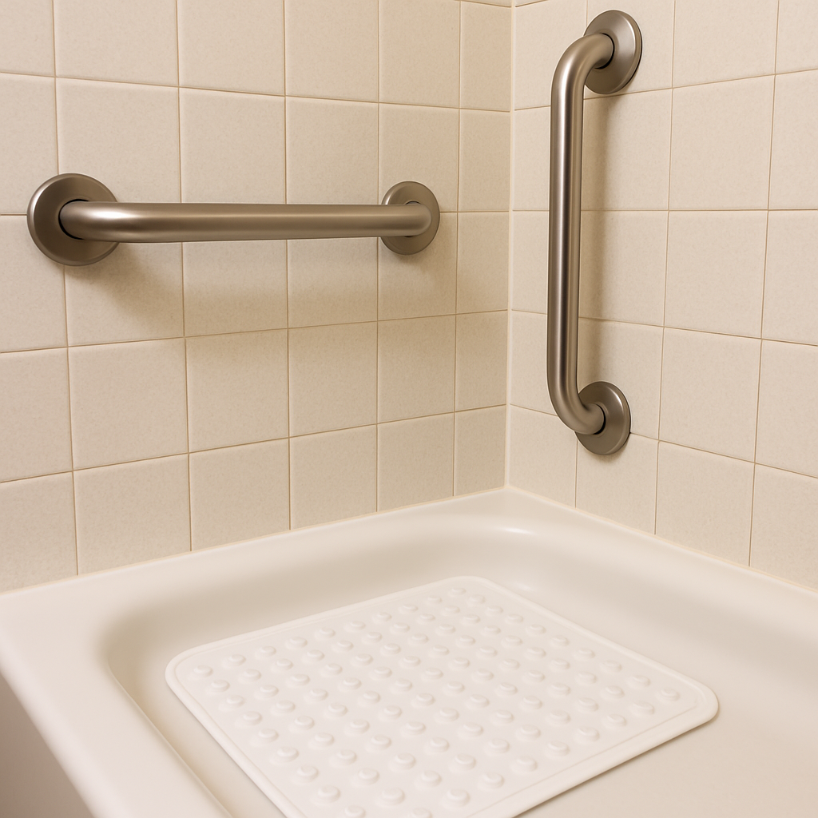
Small adjustments often yield the biggest improvements in long-term independence. OTs frequently prescribe low-tech but high-impact tools, such as raised toilet seats, long-handled reachers for dressing, or weighted utensils for shaky hands. These aren't just gadgets; they are the keys to maintaining dignity and privacy in the bathroom and kitchen. By implementing these environmental modifications early, families can drastically reduce the risk of readmission due to fractures or falls. Once the physical environment is secured and the medication is managed, the final piece of the puzzle is understanding the administrative process of officially leaving the medical facility.

Leaving the Hospital with Confidence: How the 'Hospital-to-Home' Bridge Ensures a Safe Return
Leaving the hospital feels like a victory, but the sudden silence of home can be unsettling after days of constant monitoring. This critical period, known as transitioning from hospital to home, is where gaps in care most often occur. The hospital discharge planner sends orders to the home health agency, triggering a strict timeline to ensure safety. You aren't just sent home to figure it out; a skilled nurse typically makes contact within 24 to 48 hours to reconcile new prescriptions with old ones and confirm that the home environment is safe for recovery.
While nurses handle physical wounds, another team member addresses the logistical stress. Many families wonder who qualifies for medical social worker visits, often assuming they are only for severe crisis situations. In reality, a Medical Social Worker (MSW) acts as a navigator for the confusing "business" of recovery. They help families interpret insurance coverage, apply for long-term community resources like Meals on Wheels, and facilitate emotional counseling for life-changing diagnoses. If the nurse is the doctor’s eyes, the MSW is the family’s advocate, ensuring that financial or emotional hurdles don't derail the healing process.
To manage this whirlwind effectively, focus on these immediate priorities once you walk through the door:
- Confirm appointments: Ensure you know exactly when the nurse is arriving for the admission visit.
- Secure medications: Pick up all new prescriptions immediately to avoid missed doses.
- Clear the deck: Remove throw rugs and clear pathways for walkers or wheelchairs.
- Organize paperwork: Have your hospital discharge papers on the kitchen table for the visiting nurse.
Once the immediate dust settles, the long-term success of your recovery depends heavily on the specific agency you choose to partner with.

Selecting Your Support Team: 5 Non-Negotiable Questions for Home Health Agencies
While hospital discharge planners often recommend a list of local providers, federal law guarantees your right to choose the specific community home health care agency that enters your home. This decision is crucial because quality varies significantly between providers. Your first filter should always be accreditation. Look for agencies approved by the Joint Commission (JCAHO) or the Community Health Accreditation Partner (CHAP). These seals of approval indicate the agency has voluntarily undergone rigorous inspections regarding patient safety and vetting protocols, ensuring the staff members walking into your bedroom have been background-checked and professionally trained.
Beyond certifications, the agency’s responsiveness during your initial inquiry often predicts how they will handle a medical issue in the middle of the night. You need a partner who values clear communication over sales pitches. When you make that first phone call, pay attention to the intake process—is it a knowledgeable clinical manager or an automated maze? If you struggle to get a clear answer when you are looking to hire them, it is a significant red flag regarding their reliability once the contract is signed.
To separate high-quality providers from the rest, use this script when evaluating how to choose a home health agency:
- Are you Medicare-certified and capable of direct billing?
- Do you have a registered nurse on-call 24 hours a day, 7 days a week?
- Are all staff members required to undergo criminal background checks and drug screenings?
- Will we see the same nurse and therapist for every visit to ensure consistency?
- Can you provide references from local doctors or recent patients?
Once you have identified a trustworthy team, the final hurdle is understanding the financial landscape, specifically regarding what insurance covers versus out-of-pocket costs for palliative and respite support.

Paying for Care: Navigating Palliative Care Costs and Respite Support
Untangling expenses starts with distinguishing hospice from palliative care. While hospice is fully covered by Medicare for end-of-life situations, palliative care at home cost structures differ because they allow you to continue curative treatments. Medicare Part B usually covers these symptom-management visits like standard doctor appointments, though they are often subject to typical copays. This distinction ensures patients receive comfort care for serious illnesses, such as heart failure, without abandoning their recovery efforts.
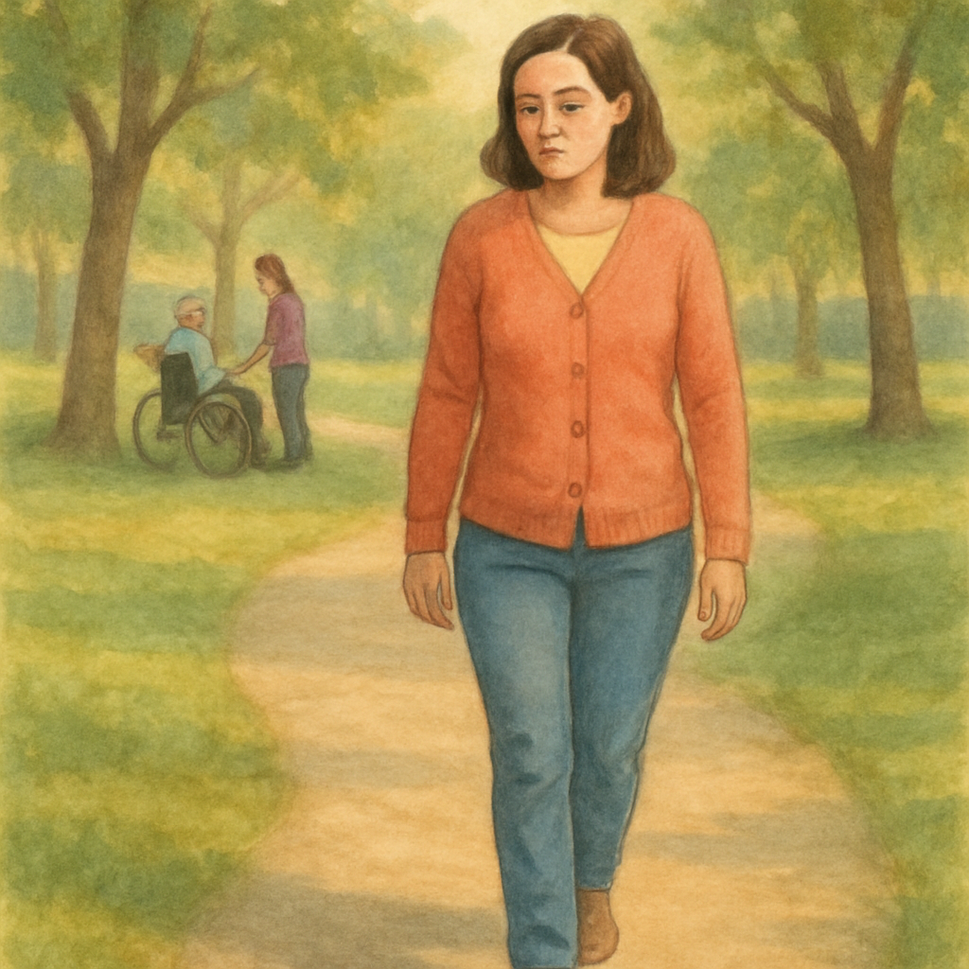
The sustainability of home health relies heavily on the well-being of the primary support person. Respite care for family caregivers provides a temporary break—ranging from a few hours to several days—allowing you to recharge without compromising your loved one's safety. While Medicare coverage for respite is largely limited to hospice scenarios, long-term care insurance and state Medicaid waivers often cover these breaks. Protecting your own mental health is a necessary strategy to prevent burnout, not a luxury.
If insurance gaps remain, local resources can frequently help bridge the difference. Area Agencies on Aging often distribute financial assistance for elderly home services through grants designed to keep seniors in their communities rather than expensive nursing facilities. Veterans may also qualify for specific VA home support benefits. With the finances clarified and your team selected, you are ready to execute your plan using the following step-by-step roadmap.

Your 3-Step Action Plan to Starting Community Home Health Care Today
Understanding the mechanics of community home health care transforms a scary discharge date into a manageable plan. You no longer have to view recovery as a burden to shoulder alone, but as a structured medical process that happens safely within your own walls. The mystery of who pays and who qualifies has been replaced by a clear roadmap for getting the support your loved one needs. The system is complex, but your role within it is now defined and powerful.
Take this new confidence into your next doctor’s visit. Instead of waiting for a suggestion, actively ask if your family member’s condition warrants a home health evaluation. When speaking with potential agencies, look beyond the glossy brochures and ask specifically about staff consistency and communication protocols. You now have the vocabulary to demand clear answers about skilled nursing visits and therapy schedules, ensuring the agency you choose is truly the right fit for your situation.
As you wait for that first knock on the door, turn a critical eye to the living environment. Clearing a path for a walker or organizing a specific station for medical supplies are small but vital steps that bridge the gap between a private residence and a functional recovery space. These physical preparations signal to the incoming care team that you are an active, informed partner ready to facilitate the healing process.
Ultimately, the goal extends far beyond healing wounds or relearning how to walk. It is about preserving the dignity that comes with sleeping in one’s own bed and maintaining daily routines. By leveraging these aging in place benefits, you are choosing a path that prioritizes safety without sacrificing the comfort of home, ensuring the next chapter is defined by independence rather than limitation.

